**Name:** Luiz Fernando de Andrade Gadelha

Edmael Fortune

Eden Bereda

**CarRentMIU: Use Case Description**

|  |  |  |
| --- | --- | --- |
| **Use Case Number: 1** | | |
| **Name:** Customer Profile CRUD | | |
| **Brief description:** This use case allows the admin and customer to create profiles for Customers | | |
| **Actor:** Admin, Customer | | |
|  | | |
| **Preconditions** | | |
| The Admin or Customer must be logged in to the system | | |
| **Flow of Events:** | | |
| **1.Basic Flows** | | |
| **1.1.0 Create Customer Profile** | | |
| **Step** | **User Action** | **System Action** |
| **1** | The Admin or Customer calls the create Customer profile command | The system displays the Customer profile form with the fields for firstname, lastname, email, password, drivers license number |
| **2** | The Admin or Customer fills out the form and request the system to save | The system verifies that there’s no other profile in the database with the same driver license number and saves the Customer and returns the success message on success or a fail message in case of failure. In case another profile exists with the driver's license number, the system returns the message indicating a duplicate entry exists. |
| **Postconditions** | | |
| The Customer profile is persisted in the system | | |
|  | | |
| **Business Rules** | | |
| No duplicates customer profiles. A unique profile is identified by driver’s license number | | |
|  | | |
| **1.1.1 Read/view Customer profile** | | |
| **Step** | **User Action** | **System Action** |
| **1** | The Admin or Customer selects to view a list of faculty profiles | The system returns a list of all Customers profiles. |
| **2** | The Admin selects to view a profile of one of the customers from the list of profiles | The system returns the profile of the Customers as a string with the names (firstname and lastname), email, and drivers license |
| **1.1.2 Update Customer Profile** | | |
| **Step** | **User Action** | **System Action** |
| **1** | The Admin or Customer selects to view a list of faculty profiles | The system returns a list of all customers profiles |
| **2** | The Admin or Customer Selects the profile of the faculty they  want to update | The system displays an editable customer profile form pre-populated with the customer profile details |
| **Postconditions** | | |
| The Customer profile will be updated | | |
|  | | |
| **Business Rules** | | |
| The Driver’s license number should be non-writable | | |
| **1.1.3 Delete Customer Profile** | | |
| **Step** | **User Action** | **System Action** |
| **1** | The Admin selects to view a list of customers profiles | The system returns a list of all faculty profiles. |
| **2** | The Admin selects to delete a customer profile from a list of customer profiles | The system displays a confirmation dialogue  window |
| **3** | The Admin selects OK on the confirmation dialog window to confirm deleting the profile | The system confirms that the customer was deleted. The system returns a success message on success or a failure message. The system should return a message indicating the profile could not be deleted because it is already assigned to some car rent |
| **Postconditions** | | |
| The Customer profile will be deleted | | |
|  | | |
| **Business Rules** | | |
| Only customers not assigned to any car rent and with no fine can be deleted | | |
|  | | |

**USE CASE DIAGRAM - CUSTOMER CRUD DIAGRAM**

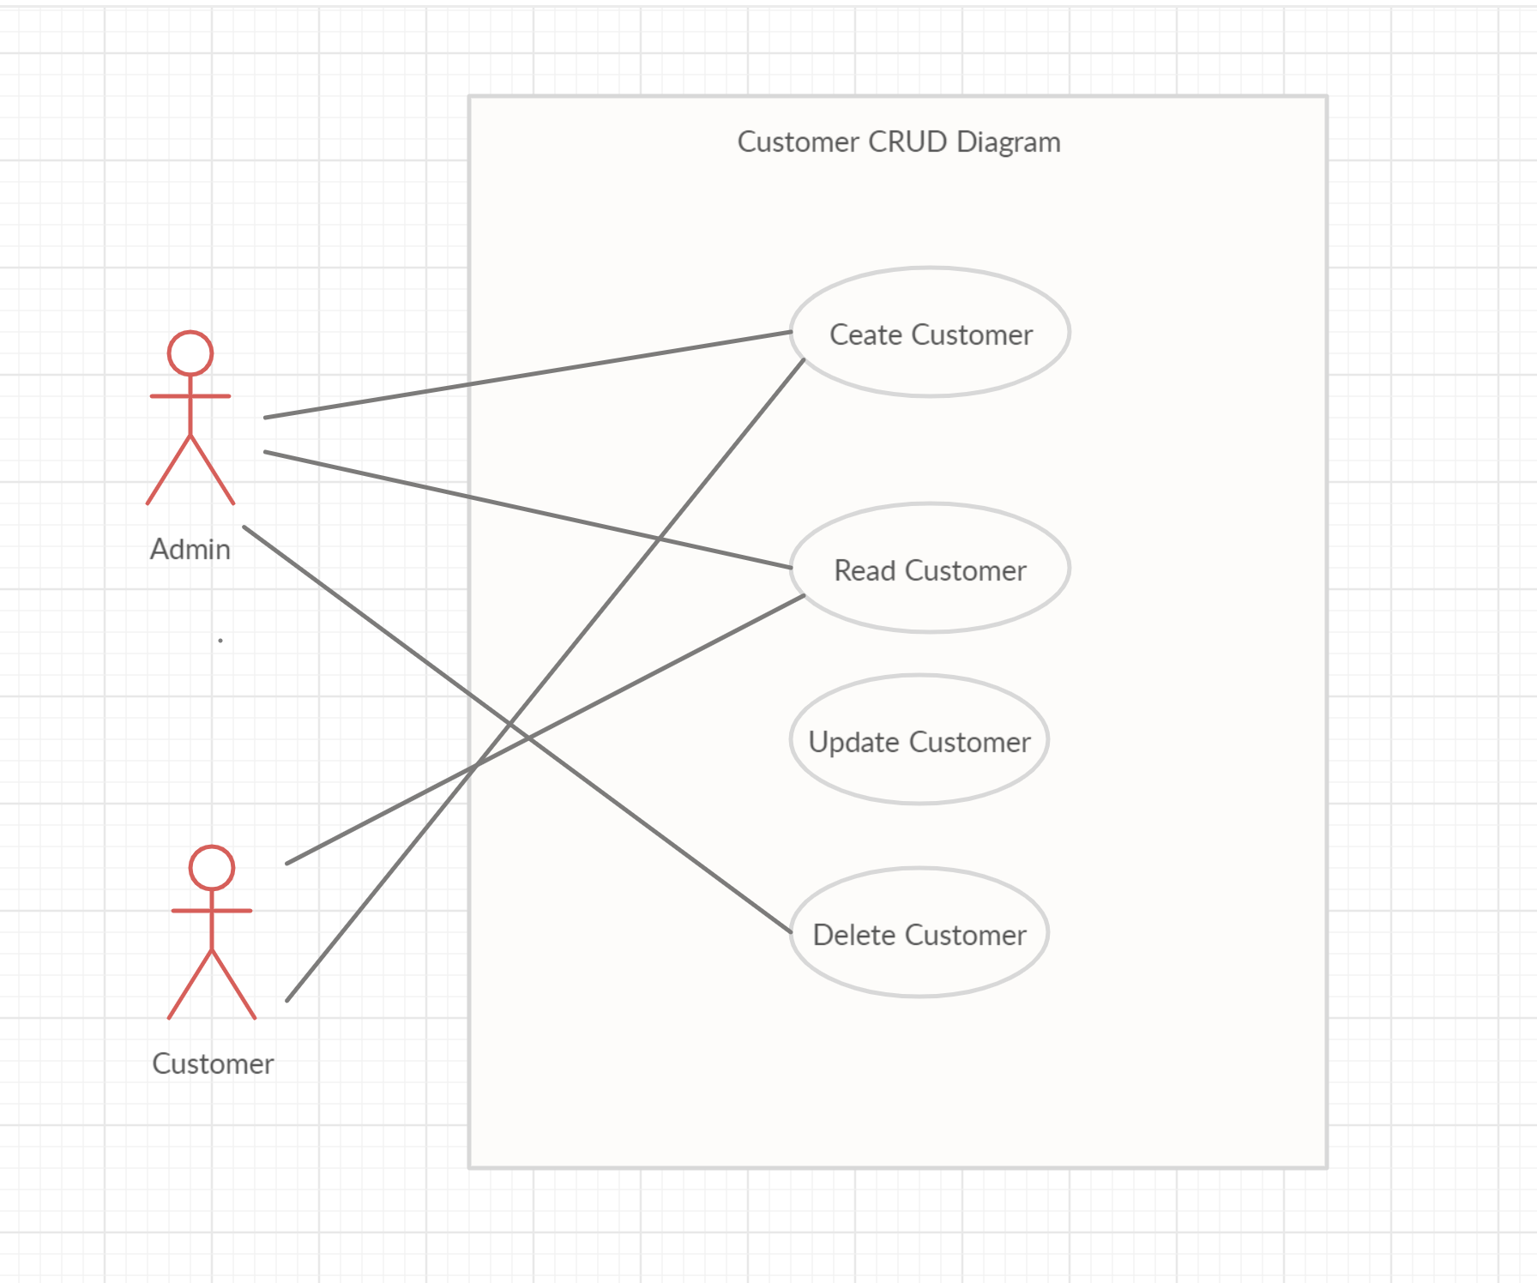

|  |  |  |
| --- | --- | --- |
| **User Case Number: 2** | | |
| **Name:** Car Profile CRUD | | |
| **Brief description:** This use case allows the admin to create profiles for car | | |
| **Actors:** Admin | | |
|  | | |
| **Preconditions** | | |
| The admin must log in to the system | | |
|  | | |
| **Flows of Events** | | |
|  | | |
| **1. Basic Flows** | | |
| **1.1.0 Add Car Profile** | | |
| **Step** | **User Actions** | **System Actions** |
| 1 | The admin calls the add car profile command | The system displays the car profile form with the fields for mark, model, registrationNumber, productionYear, rentPrice, category |
| 2 | The Admin fills out the form and request the system to save the details | The system verifies that there’s no other profile in the database with the same registration number and save the car profile and returns the success message on success or a fail message in case of failure. In case another profile exists with the registration number, the system returns the message indicating a duplicate entry exists. |
| **Postconditions** | | |
| The car profile is persisted in the system | | |
|  | | |
| **Business Rules** | | |
| No duplicate car profiles. A unique profile is identified by a registration number | | |
|  | | |
| **1.1.1 Read/view Car Profile** | | |
| **Step** | **User Actions** | **System Actions** |
| 1 | The admin selects to view a list of car profiles | The system returns a list of all car profiles |
| 2 | The admin selects to view a profile of one of the car from the list of profiles | The system returns the profile of the car as a string with mark, model, productionYear, rentPrice, category |
|  | | |
| **1.1.2 Update Car Profile** | | |
| **Step** | **User Actions** | **System Action** |
| 1 | The admin selects to view a list of car profiles | The system returns a list of all car profiles |
| 2 | The admin selects the profile of the car they want to update | The system displays an editable car profile form pre-populated with the car profile details |
| 3 | The admin updates the fields they want to update and requests system to save the new details | The system update the record and returns the success message or a fail message on exception |
| **Postconditions** | | |
| The car profile will be updated | | |
| **Business Rule** | | |
| The registration number should be unwritable | | |
|  | | |
| **1.1.3 Delete Car Profile** | | |
| **Step** | **User Actions** | **System Actions** |
| 1 | The admin selects to view a list of car profiles | The system returns a list of all car profiles |
| 2 | The admin selects to delete a car profile from a list of car profiles | The system displays a confirmation dialogue window |
| 3 | The admin selects OK on the confirmation dialog window to confirm deleting the profile | The system checks to confirm the car is not assigned to any customer. The system returns a success message on success, or failure message. It must also return a specific message when the car is assigned to some customer. |
| **Postconditions** | | |
| The car profile will be deleted | | |
| **Business Rule** | | |
| The car must have not been assigned to any of the customers | | |
|  | | |

**USE CASE DIAGRAM - CAR CRUD DIAGRAM**

